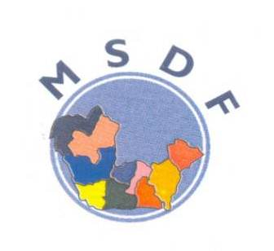
MORGAN SMART DEVELOPMENT
FOUNDATION (MSDF)

Empowering Women and Youths, uplifting Communities
2016 ANNUAL REPORT
Warri Secretariat:
6 Oki Street, Okere, Warri, Delta State
Phone: 08033960048, 08039171045
Lagos Office:
No 4 Our Saviour Street, Gbara-Lekki off Beachgate Hotel Road, (Jakande Roundabout), Lekki- Epe Expressway, Lagos State.
Email:morganfoundation@yahoo.com
Website: www.morgansmartfoundation.org

Vision Statement
A Strong Organisation promoting sustainable development in an economically prosperous nation, and Empowered Women and Youths in the Niger Delta Region

Mission Statement
...Working with other stakeholders in the public and private sectors, to develop the capacities of the under- privileged, especially women and youths through training, mentoring and provision of micro support, to ensure sustainable development in the Niger Delta Region.

Core Values
- Transparency and accountability to all its stakeholders in the Design, implementation and reporting of projects and activities
- Gender equity
- Sound and participatory project conceptualization and delivery.
- Provision of leadership trainings and building of leaders
- Equal employment opportunity and all round human resource development
- Passion and zeal
- Innovation and creativity
- Environmental sustainability

Contents
- . Message From The President of The Foundation
- Introduction To Morgan Smart Development Foundation
- Achievements In 2016
  - Economic Empowerment (EE)
  - Training On Use of Improved Chorkor Fish Smoking Ovens and Business Management Workshops for Selected Women in Delta, Edo and Ondo States.
- Retainer-Ship by Chevron Nigeria Limited (CNL) to provide Technical Services to the Itsekiri Rdc, Ilaje Rdc and Aicecum CCDC through Its Global Memorandum Of Understanding (GMOU).
4.1. Activities Carried Out In Itsekiri Regional Development Council
4.2. Activities Carried Out In Ilaje Rdc And Aicecum CCDC in Ondo State.
- Morgan Smart Membership Of A 4 Members Consortium of the Participatory Partnership For Community Development (PPCD)
- Scholarship Program under the MSDF Educational Assistance Program (EAP).
- The Federal Government Social Investment Program(Sip) Participation in Implementation in the Home Grown School Feeding Program in Warri South LGA, Delta State.
- MSDF organised a three (3) days excursion to Lagos for some MSDF sponsored students.
- Morgan Smart Dev Foundation (MSDF) Celebrates 2016 International Women’s Day in Warri.
- The Federal Government Social Investment Program(Sip) Participation In Implementation In The Home Grown School Feeding Program In Warri South LGA, Delta State.
- Activities of the Morgan Smart Youth For Peace Network (MYPN)
  - Registration of youths of the Morgan Smart Youth for Peace Network in the Npower Scheme.
  - Registration of women and youths for the Federal Government Enterprise Empowerment Program (GEEP).
  - Morgan Smart Youth for Peace (MTPN) engagement with the Pind 4 Peace (P4P)
- Activities of MSDF CEO/President in the Year 2016.
- Looking Ahead To 2017
- Photo of the staffs of MSDF

- Message from the President of the Foundation

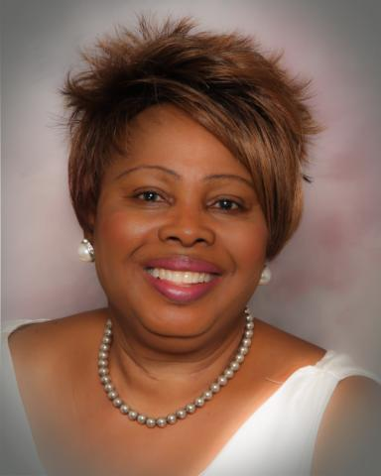
It is with great joy that I present to you Our Dear Partners, Stakeholders, Trustees, members of the Foundation and the general public, the 2016 Report of the Activities of Morgan Smart Development Foundation. The Foundation was endowed in the year 2002 in memory of my late father Mr Morgan Smart Urhobo and has over the past 14 years worked assiduously to impact in its own modest ways, in poverty alleviation and sustainable development of the Niger Delta Region of Nigeria and the Country at large.
The Foundation has worked hard in the implementation of programs and projects that are targeted at uplifting especially the poor and deprived women and youths in the Niger Delta through building of their capacity and exposing them to income generation workshops and exhibitions, developing their leadership skills and other skills acquisitions projects, technical support, scholarship, micro projects and access to micro credit facilities in collaboration with the Coastline Micro Finance Bank, Okere Warri Delta State Nigeria in which the Foundation has investments etc.
The endemic poverty that continues to exist in the Niger Delta Region of Nigeria inspite of efforts of Governments at various levels and the oil companies to alleviate it, have continued to be of great concern to all people of conscience in the Region. The endemic youth’s employment remains a serious challenge in the region with the resultant youth restiveness, militancy, kidnapping, pipeline vandalism and other negative vices that have serious economic consequences for the region and the country. It is however unfortunate that the economic neglect and deprivation being suffered in the region have greater effect on the poor women in the rural and urban areas of the Niger Delta. The exploration activities of the oil companies and pipeline vandalism continues to reck havoc on the eco- system with heavy environmental pollution of the water ways that has serious consequence on the natural livelihood activities of the women in the riverine communities which is fishing. Across the Niger Delta evidence abound of the immeasurably suffering which the women go through to irk a living and who paradoxically in most cases are also the breadwinners in their home and family.

The announcement by the Federal Government of Nigeria of its N500 billion Social Investment Program (SIP) intervention Fund targeted at women and youths in the rural communities seems to represent some beacon of light, as the program is targeted at empowering the poor women and youths in the country. The Foundation is expecting that this would translate into assuaging the suffering of the women and youths in Nigeria especially those in the Niger Delta Region. The Foundation played some role in the implementation of the SIP process when she was appointed by the Delta State Government as the NGO member of the SOCU committee constituted to implement the Social Investment Program (SIP) in Warri South Local Government area of the State.

The Morgan Smart Development Foundation in its own modest ways continue to impact by helping to add value to development in the Region through the activities that have been vividly captured in this 2016 Report. To achieve sustainable development of the Niger Delta, there is no doubt that a lot of work still need to be done by the various government intervention agencies, multinational companies, local governments councils and even the Non-Government Organisations to bring some relief to the abject poverty to which the people of the region are condemn to presently. The Morgan Smart Scholarship program for secondary students from financially challenged homes continues to remain a success story for the Foundation with over 100 students on her scholarship as at 2006.

The Foundation in carrying out its activities in the Niger Delta are greatly limited by paucity of Fund to meet the developmental gaps that need urgent attention especially in the area of Water and sanitation, Education, Health, Family Planning, Income Generation Activities and Economic Empowerment, Introduction of Local technology to women involved in food processing to have a more efficient way of local production of food to create wealth remains a panacea for creating wealth for women of the Region. The Foundation therefore continues to solicit for partners and sponsor for her various programs and projects.
For in the year 2016, the Foundation wishes to express her sincere gratitude and appreciation to all our partners, sponsors, donors and friends who through their immeasurable support have made all what the Foundation achieved in the year possible.
The Foundation wishes to reiterate it commitment to sustainable economic and social development of Nigeria especially the Niger Delta Region and will continue to seek partners and sponsors to execute programs and projects that will bring some peace and prosperity for our long suffering women and youths of the Region.
Thank you and God bless

Dr Omawumi Evelyn Urhobo
President/CEO
2016

- INTRODUCTION TO MSDF

The Morgan Smart Development Foundation (MSDF) is a non-Governmental Organization (NGO) dedicated to the empowerment of rural and urban poor women and youths in Nigeria for poverty reduction, employment generation and sustainable socio-economic empowerment. Over the last Fourteen(14) years of its establishment, the Foundation has recorded series of achievement through its five (5) thematic areas of activities that included: Economic Empowerment (EE) Micro Project Implementation (MPI), Capacity Building/Leadership Training (CB/LT), Communication, Advocacy and Gender Mainstreaming (CAG), Peace Building/Conflict Resolution (PB/CR).

The Foundation is registered with the Corporate Affairs Commission (CAC) Abuja, National Planning Commission Abuja, the Federal Ministry of Women Affairs and Social Development, Abuja, Delta State Ministry of Youths and Sports, Asaba and the Lagos State Ministry of Women Affairs, Lagos State. The Foundation has its Head Office in Lagos, an Operational Office in Warri, Delta State with Liaison offices in Abuja and Igbokoda in Ondo State.

CORE AREAS OF INTERVENTION BY THE FOUNDATION
The activities of the Foundation where carried out through its five (5) thematic areas of intervention. They included:

Economic Empowerment (EE):
The economic empowerment programs of the Foundation is geared toward promoting income generating opportunities for poor and deprived women and youths to enable them contribute meaningfully to sustainable development of the country. The Empowerment program focuses on;

Human Capital Development: Through scholarship, provision of income generation vocation for the girl child, and building the capacity of the poor women and youths to identify economic opportunities to improve their livelihood status.

Implementation of Enterprise Development Programs by helping to improve the access of poor women and youths to micro credit, grants, income generating equipment, agricultural raw materials and subsidies. To also help to transfer information on new technology to improve local production to enable the women and youths to build viable enterprises, earn higher income and improve on their livelihood status thereby alleviating poverty.

Micro Projects Implementation: (MPI)
This is to pursue an effective intervention in the lives of women and youths in rural communities through the provision of micro-projects that supports the Sustainable Development Goals (SDG's) especially in very poor and neglected communities with intervention that directly impact positively in their lives. Such interventions include provision of Clean Water, Sanitation, Health Centers, and Schools etc. which are almost non-existent in a lot of the rural communities in Nigeria.

Capacity Building/ Leadership Training (CB&LT) Programs:
This program provides continuous capacity/skill acquisition trainings for youths and women which are now being conveniently carried out in the Morgan Smart Women and Empowerment Resource centre in Warri inaugurated in Dec 2013. There is also the periodic leadership training programs for community women leaders and youths to empower them to participate effectively in the decision making processes in their communities and the country at large. This the Foundation achieved through the hosting of workshops, seminars, conferences and exhibitions.

Peace Building/Conflict Resolution (PB/CR):
This area focuses on strengthening conflict resolution mechanism in warring communities using conflict resolution tools that includes the Alternative Dispute Resolution (ADR) mechanism to help communities to resolve conflicts. . This is to enable communities to benefit from development projects that they are deprived of, when conflict persists.

Communications, Advocacy and Gender (CA&G):
This thematic area focuses on sensitization of Government at all level and other stakeholders on issues of rampant poverty especially amongst the women in Nigeria especially the Niger Delta and is presently spearheading a campaign about the Conspiracy of silence against the women of the Niger Delta as there is no evidence of Government at any level address the endemic poverty that is prevalent amongst the women in the region either is anyone talking about it. There is still the serious case of Gender inequality that women still suffer in Nigeria and the need to push for Gender mainstreaming at all levels of social and political interaction for women in the country. There are also challenges of the crisis of Widowhood and that of the Girl Child that the Foundation advocates on. The health challenges of HIV/AID and Malaria are also areas of great concern to the Foundation.

- ACHIEVEMENTS IN 2016
  - Economic Empowerment (EE)
    - Training On Use of Improved Chorkor Fish Smoking Ovens and Business Management Workshops for Selected Women in Delta, Edo and Ondo States.
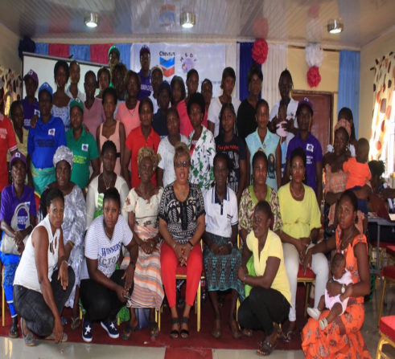
This is grounded on the Economic Empowerment Partnership between MSDF and French Embassy (SDF) and Chevron International (i-triple-E) in 2014 and 2015 to construct and train over 450 poor rural women on the use of thirty five (35) improved Chokor fish Smoking Oven Technology in Edo, Ondo and Delta States.

Morgan Smart Development foundation in conjunction with the French embassy and PIND foundation organized a four day business management workshop on the use of Chorkor Fish Smoking Oven to women beneficiaries from cooperative groups in Edo / Ondo State. The workshop had 24 participants and was held at the Morgan Smart Women and Youth Resource Centre, No 19 Oki Street off Okere road; Warri, Delta State. It took place from Monday 29th of February, 2016 to Tuesday 1st of March, 2016.
The Foundation in collaboration with Chevron Corporation under its Triple-E also organized a four day training workshop on the use of Chorkor Fish Smoking Oven to women from 15 cooperative groups in targeted Itsekiri and Ilaje regional development councils in Delta / Ondo State. The workshop had 150 participants and was held at the Morgan Smart Women and Youth Resource Centre, No 19 Oki Street off Okere road; Warri, Delta State. It took place from Monday 7th of March, 2016 to Thursday 10th of March, 2016
Dr Omawumi E. Urhobo President/CEO in a group photo with women from Ilaje, Itsekiri and Edo State that participated in the business management workshop held in Warri.
The workshops were specially designed to build the capacities of the women participants on usage of Chorkor Fish Smoking Oven in their different communities to enable them acquire new and advance skills which will enable them to earn a better income on their fish smoking business.

The participants acquired new and advanced skills in various areas in which they need to advance their business which include; the use of the new Chorkor Fish Smoking Oven, Fish Farm Business Cycles, Keeping Fish Farm Business Record, Purchasing Decisions, Value Chain and Market Analysis, Basics of Cash Flow, Savings and Credit Management, Keeping proper financial record of their business and the importance of belonging to a cooperative group.

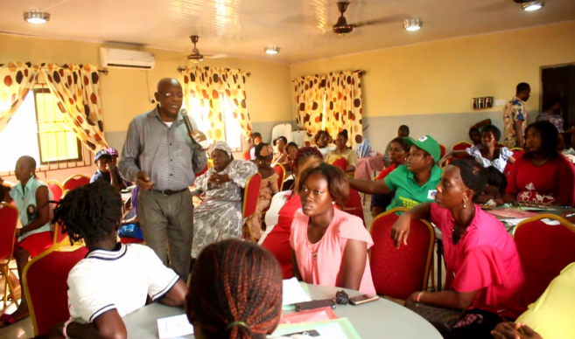

- Retainer-ship by Chevron Nigeria Limited (CNL) to provide technical services to the Itsekiri RDC, Ilaje RDC and AICECUM CCDC through its Global Memorandum of Understanding (GMoU).

T

he Foundation in the year under review continued with its technical support/guidance to the Ilaje Regional Development Council and AICECUM CCDC under the CNL General Memorandum of Understanding (GMoU) with its oil impacted communities for which the Foundation was engaged by Chevron Nig. Ltd.
4.1. ACTIVITIES CARRIED OUT IN ITSEKIRI REGIONAL DEVELOPMENT COUNCIL
4.1.1. MSDF in its capacity as mentoring NGO to the Itsekiri RDC started the year with the new team lead of Chevron in planning to engage the Secretary to the Olu of Warri, to get the blessing of the Olu to convene a meeting with the members of the Itsekiri RDC, Chevron and other Stakeholders, to discuss the issues affecting the Itsekiri RDC especially on the possibility of intervening in the challenges of the transition issue of the RDC.

4.1.2. MSDF in its capacity as the Chairman of the PRC committee of the Itsekiri RDC attended the Ijaw and Itsekiri Agripreneur Launch: The Ijaw and Itsekiri Agripreneur Launch was held on the 11th of February 2016 at Partnership Initiatives in the Niger Delta (PIND) office at Egbokodo Itsekiri, warri. The Agripreneur Launch was an outcome of an Economic Growth Opportunity study carried out by CNL in the communities which identified agriculture as a means to stimulate socio-economic development using agribusiness for income generation and provision of employment for Youths in the communities. CNL is partnering with the International Institute for Tropical Agriculture (IITA) in the project. The Foundation for Partnership Initiative in the Niger Delta (PIND) Egbema-Gberamatu Communities Development Foundation (EGCDF) and the Itsekiri Region Development Committee (RDC), are to implement the pilot programme with the training of 40 youths, 20 from each of the two RDCS. The training commenced in March 2016, at IITA Ibadan and PIND Egbokodo, Warri. While practical demonstration farms will be established at the various communities

4.2. ACTIVITIES CARRIED OUT IN ILAJE RDC AND AICECUM CCDC IN ONDO STATE
4.2.1. ENGAGEMENT WITH THE OLUGBO OF UGBO.
MSDF in its capacity as the mentoring NGO of Ilaje RDC, participated in the Ilaje RDC and AICECUM interactive forum with the Olugbo of Ugbo, Oba Fredrick Akinruntan and other traditional leaders on June 14th, 2016 at his palace. The interactive forum allowed for the Introduction of the GMoU Process, where the GMoU Governance Structure was analyzed in its totality. The roles of Stakeholders were also brought to the fore. Details of the Old Community Engagement Model and its drawbacks were discussed, thereafter, the current GMoU/OMoU Community Development Model, its objectives and key concepts was fully brought to the attention of all in attendance.

4.2.2. MSDF Chairmanship of the Project Review Committee (PRC) of the Ilaje Regional Development Council (ILRDC)

The Foundation in its capacity as chairman of the Project Review Committee (PRC) Sub-Committee of the Ilaje RDC successfully provided technical guidance in the following areas;

- GMOU TRAINING ACTIVITIES
  - Media engagement training organized by PPCD for RDC members of the Communication Committee. The training was held on June 1st and 2nd, 2016 at PPCD Office, Effurun GRA, Effurun, Delta State.
  - Leadership and social mobilization training for Ilaje RDC and AICECUM members as well as community leaders. The training held on 15th June, 2016 at De Dons Restaurant Hall, Okitipupa, and Ondo State.
  - Facilitated in the communications training workshop organized by PPCD for RDCs and CCDCs. The training took place from 17th August – 18th August 2016 at PPCD office in Warri

  - Facilitated in a PRC Manual Training for Ilaje RDC PRC, AICECUM-PEC, Government, NGOs, RDC Reps and CNL on July 27th, 2016 at Okitipupa. The training included assessment of the application of the Manual in the operations of the PRC, identification of gaps in the application of the PRC Manual and proffering solutions including adoption of best practices.

  - Facilitated in a RDC Gender Forum and Community Leaders’ Engagement Meeting. A two-day Gender forum and community leaders’ engagement meeting was held in ilaje Regional Development Committee (IRDC) at Awoye and Molutehin communities to educate the women and the elders on the concept of Global Memorandum of Understanding (GMoU) and create awareness on the importance of women inclusion in the GMoU process.

- Monitoring Of On-Going Projects in Ilaje Regional Council impacted communities.

MSDF in its capacity as Chairman of the Project Review Committee (PRC) led a team of PRC members to carryout monitoring visits to Awoye and Molutehin on May 25th, 2016 in order to ascertain the current situation with the Reverse Osmosis Water Development Project in Awoye and Molutehin. The committee also inspected the ongoing 2016 Improved Wooden (Composite) Walkway Projects in the IRDC Communities in December, 2016.
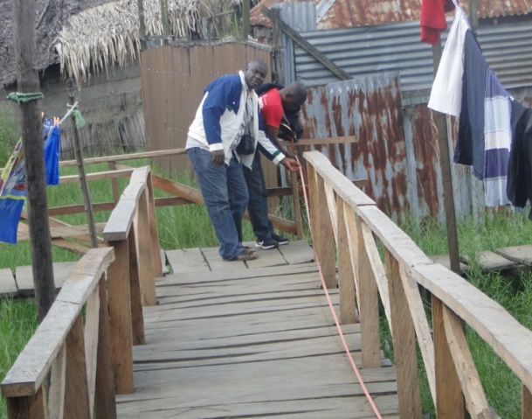

- MSDF Chairmanship of the Project Execution Committee (PEC) of the AICECUM CCDC

MSDF as Chairman of the Ilaje AICECUM Project Execution Committee (PEC) led a Project Assessment Team visit to 23 Communities in preparation for the implementation of the AICECUM 2016 improved wooden walkway projects in July, 2016.

- MSDF as member of the Ilaje AICECUM Project Execution Committee (PEC) lead the team on a project monitoring visit to the ongoing 2016 Improved Wooden (Composite) Walkway Projects in the AICECUM Communities.

- MORGAN SMART MEMBERSHIP OF A 4 MEMBERS CONSORTIUM OF THE PARTICIPATORY PARTNERSHIP FOR COMMUNITY DEVELOPMENT (PPCD)
M

organ Smart Development Foundation (MSDF) as a Member of the 4 Member Consortiums of NGOs participated in all committees activities of the PPDC during the year under review. The Standing Committees of the PPCD includes the PPCD Planning Committee which coordinates the activities of the PPDD of which the MSDF is a member. Other sub committees includes the Communication Subcommittee, Gender Subcommittee, Institutional Building and Resource Mobilization subcommittee, Monitoring and Evaluation (M&E), Advocacy subcommittees.
The MSDF as part of the PPCD Consortium NG0s participated and facilitated several training workshops organized by the PPCD. Some of the workshops included the On-Boarding Training for RDCs and quarterly committee meetings.

- SCHOLARSHIP PROGRAM UNDER THE MSDF EDUCATIONAL ASSISTANCE PROGRAM (EAP)

MORGAN SMART DEVELOPMENT FOUNDATION (MSDF) 6TH SCHOLARSHIP AWARD CEREMONY
In an inspiring award ceremony held on the 16th of February, 2016 at the Morgan Smart Development Foundation Resource Centre; MSDF has made its largest ever award of scholarship under its education assistance scheme. 25 indigent but intelligent children selected from secondary schools in Delta State were awarded scholarship; the awardees include 18 girls and 7 boys.

With the granting of awards to 25 new beneficiaries, the Foundation has over the past 6 years successfully provided scholarship opportunity to 101 indigent but intelligent children. While expressing her joy and sense of fulfillment at this achievement, Dr. Evelyn Atsiangbe Urhobo, President/CEO, MSDF declared that the Foundation has increased its target to 500 students, encouraging friends and well-wishers to donate and support the Foundation in this scheme; explaining that it costs N25, 000 to sponsor a child every year.
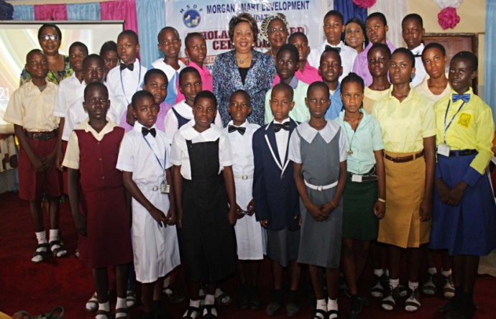
The Chairman of the occasion Dame Florence Ehinlaiye (Proprietress of Twin Fountain Group of Schools, Warri), lauded Morgan Smart Development Foundation (MSDF) for its noble efforts, she gave a personal testimony of her own scholarship experience, recalling that the privilege of a scholarship made it possible for her to acquire the education that has elevated her to her present status. She went ahead to advice the recipients to give their education the priority it deserves and stay away from all forms of bad company, academic laziness, truancy etc.
High points of the occasion included presentation of the award letters and the customary scholarship kit (new set of school uniforms, school bags, school shoes, note books, text books) by the Chief Inspector of Education; Warri South Local Govt. Area, Dr Michael Emeshili and other notable guests present at the ceremony.
In a very emotional response to the presentation of the awards, Mrs Toki, a parent to one of the students; speaking on behalf of the other parents, expressed their heart felt gratitude to the foundation for the intervention and the huge financial relief it will be to them, and that above all, the assurance that their children will complete their secondary education without hassle was indeed a source of great joy to them.

Group photograph of scholarship beneficiaries with MSDF President/CEO at the event
Dr Omawumi E. Urhobo President/CEO MSDF in a group photo with beneficiaries of the 201 6 Scholarship Award.
CIE, Dr. Emeshili presenting scholarship material ls to a beneficiary

- Morgan Smart Development Foundation (MSDF), 5days Summer Camp program for 58 Students under the scholarship of the Foundation

Five days of fun, excitement, learning and pleasure... from 15th - 19th August, 2016 Morgan Smart Development Foundation held her annual summer camp program for students under the MSDF scholarship scheme. The summer camp program is aimed at engaging the students meaningfully for a few days during the summer holidays. 95 students participated in this year's summer camp program.

The activities kicked off with an opening ceremony attended by dignitaries including Dr. Evelyn Atsiangbe-Urhobo (President/CEO MSDF), school principals, parents of students amongst other dignitaries. Lauding the efforts of the foundation; from giving scholarship to indigent brilliant students, to organizing yearly summer camp activities for them, the invited guests also elaborated the benefits of engaging children positively during the long summer holidays, they called me on other organizations to emulate MSDF, while also promising to always support the foundation in all her activities.

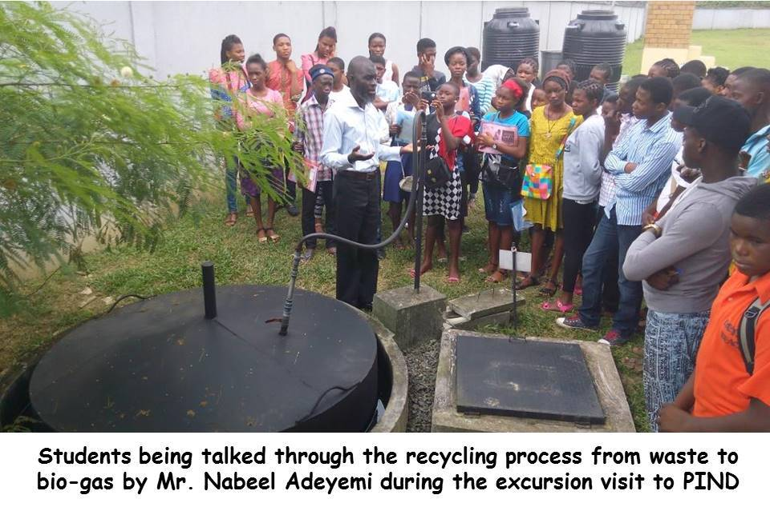
The children greatly enjoyed the camp activities which included a key note address on the theme of this year's camp "Education, the key to self-actualization" by Mrs. Jolomi Osandatuwa. There were also career counselling sessions in medicine, law, engineering, teaching ; talks on mentoring and role modeling, cultivating a reading culture, cultism, parenting and it's challenges, domestic violence and child abuse, examination malpractice, teenage pregnancy, goal setting as teens, how to manage finances etc. There was a special presentation on drug abuse by the Warri area command of the NDLEA ; practical sessions on bead making and table etiquette, a movie show and an excursion visit to the PIND ATED office and the DRTV station, all these sessions were facilitated by highly skilled professionals making it a memorable learning experience for the children. The children were also given opportunities to display their natural talents in singing, comedy, dancing, poetry and presenting.

Amidst the fun of the camp activities, the students met new friends and strengthen existing friendships built during previous summer camps. The summer camp continued with a trip to Lagos from 21st - 26th August, by the 14 top performing students in the just concluded academic session. The annual trip to Lagos is an added incentive to motivate students to work harder in their school work so as to qualify.

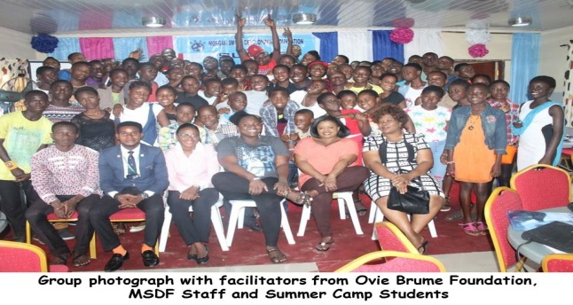

- MSDF ORGANISED A THREE (3) DAYS EXCURSION TO LAGOS FOR SOME MSDF SPONSORED STUDENTS FROM 22ND -24TH AUGUST, 2016.

The 2016 summer camp program for MSDF scholars also included a special excursion trip to Lagos for the best 10 students (6 girls and 4 boys) of the 2015/2016 academic session, which was coordinated by the staffs in Lagos office from 22nd to 24th of August, 2016. This was to reward the students who had outstanding performances in their academics and to encourage other students to work harder so as benefit from such special treat in future. The trip to Lagos included visit to interesting places such as the National Theatre, Silverbird Cinema, Nicon Beach, National Museum, Nigerian Conservation Center and The University Of Lagos, Akoka.

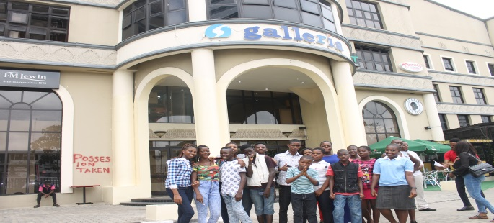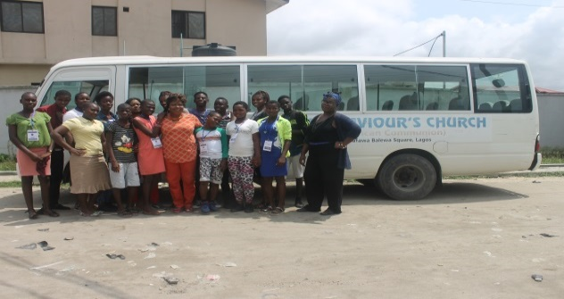
Dr Omawumi E. Urhobo President/CEO in a group photo with the best 10 MSDF scholars during the excursion in Lagos.
MSDF Scholars in front of Silverbird galleria during the Excursion in Lagos.

- MORGAN SMART DEV FOUNDATION (MSDF) CELEBRATES 2016 INTERNATIONAL WOMEN’S DAY IN WARRI

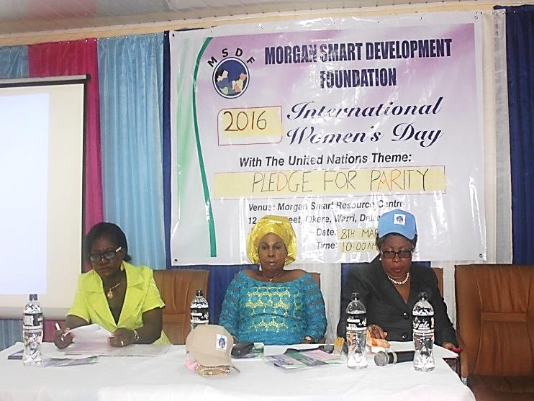
In celebration of the 2016 international women's day, Morgan Smart Development Foundation rolled out its celebration drums to honour the unique women of the Niger Delta on the 8th of March, in Warri, Delta State with the UN theme "Pledge for Parity". The event was dedicated to extolling the strength of the Niger Delta women, while calling attention to the prevalent conspiracy of silence, gender inequality and bias that they face daily.
The President/CEO of MSDF Dr Omawumi Evelyn Atsiangbe- Urhobo, in her welcome address noted that the progress so far made towards Gender parity has slowed down, and therefore urgent concrete action is required around the world to accelerate gender parity. She described the women from the Niger Delta as untapped natural resources that need to be invested in, and called on government at all level to commit to developing and empowering them; to remove them from the poverty to which they are presently condemned to in the region. Dr Urhobo called on the men who are a part of this bias to have a change of heart and elevate their women as jewels who put
L-R Lady Kate Majomi (representing the commissioner for women’s affairs), Barr Violet Ogbe (chairman of the occasion), and Dr Omawumi Urhobo
together homes and also care for children; stressing that violence and refusal to contribute to the well-being of women must stop in Nigeria and globally and every one must move from mere talk to concrete action by pledging to the cause of Gender Parity to which everyone should be prepared to play their own part.
Lady Kate Majomi, representing the Delta State Commissioner for Women Affairs,
Rev Omatshola Williams, reaffirmed the ministry's commitment to gender equality and creating opportunities for women empowerment and uplifting in Delta State.
In her keynote address, Mrs Uju Obiora, Snr Programs Manager at Participatory Partnership For Community Development (PPCD), whose presentation was read by Lady Evelyn Ideh, highlighted the milestones the World has gone through in actualizing Gender Parity with the UN 2016 of the celebration of the International Women's Day with the Theme of Gender Parity and calling on the Global Communities to committing to the struggle. She talked on the progress that Nigeria has made with regards to gender parity which includes: women's right to inheritance, eradication of obnoxious widowhood practices and the earlier need for a husband to give a consent letter from husband as a condition for issuing women international passports. She concluded by saying that much still need to be done to achieve Gender Parity and all must proceed from mere rhetoric to committing to the uplifting of the status of country in Nigeria.
A cross section of the women participants at the event
Highlights of the occasion included a talk by a health specialist on the dangers of High blood Pressure which is a silent killer and the need for women to take their health more seriously. The Celebration also included the presentation of empowerment items to 20 Women who were in dire need of financial intervention in their businesses. These items included Sewing Machines, Pepper Grinders, Mobile Food Carts, locally fabricated baking Ovens, Bead making Starter Packs, and Fishing nets. The Women beneficiaries were drawn from across the
Niger Delta, including some of the participants of the ongoing business management training for the women beneficiaries of the improved Chorkor fish smoking ovens from Itsekiri and Ilaje RDC communities. Two women from Ilaje RDC were presented with sewing machines, while one was presented with a grinding machine; two women from Itsekiri RDC also received sewing machines.
The Event also included the hosting of an Exhibition Fair, where indigenous women entrepreneurs where given the opportunity to display their wares, networking and getting markets for their products.
The over 150 women who were present at the celebration, were generally happy for the opportunity to celebrate themselves as there was a lot of food, drinks and comedy that accompanied the celebration

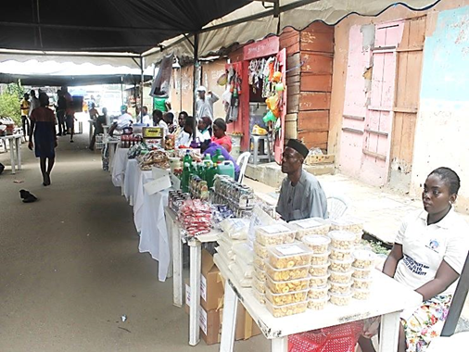
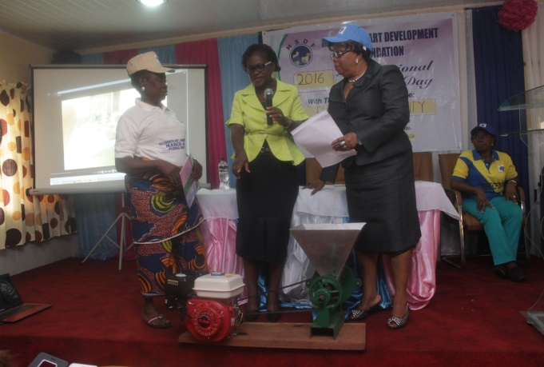
An exhibition of Local handcrafts, food and products by the women at the international women day in Warri.
One of the beneficiaries of the empowernment program being handed over a pepper grinding machine by Dr Omawumi Urhobo President/CEO MSDF.
- THE FEDERAL GOVERNMENT SOCIAL INVESTMENT PROGRAM(SIP) PARTICIPATION IN IMPLEMENTATION IN THE HOME GROWN SCHOOL FEEDING PROGRAM IN WARRI SOUTH LGA, DELTA STATE.

The Federal government Home Grown School Feeding (HGSF) program provides opportunities to assist vulnerable families feed their children while providing an incentive to send them to school. A key deliverable of this program is the Support to States in designing and implementing State-specific, national owned and locally resourced school feeding programs. Morgan Smart Development Foundation was appointed as a member of the committee set up by the Delta State Government SOCU to oversee the implementation of the program in Warri South LGA. The SOCU committee was involved in the screening of over one hundred and fifty caterers who applied to participate in the program. The screened list was then sent to Asaba for final selection. MSDF also conducted a training session for the final selected sixty four (64) caterers to sensitize them on how to handle the following:-
- Module 1:- Good food and hygiene practices.
- Module 2:- Nutrition and healthy lifestyle.
- Module 3:- Water and Sanitation.
- Module 4:- Food Storage, Preparation, Handling and Transportation.
- Module 5:- HACP Principles/Risk Control.
- Module 6:- Business management.

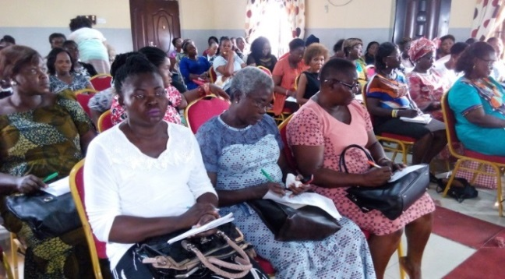
The school children feeding under the Home Grown School Feeding Program in Warri south LGA of Delta State.
The caterers selected for the Home grown school feeding program during the training program conducted by MSDF

- ACTIVITIES OF THE MORGAN SMART YOUTH FOR PEACE NETWORK (MYPN)

  - REGISTRATION OF YOUTHS OF THE MORGAN SMART YOUTH FOR PEACE NETWORK IN THE N POWER SCHEME.
The Morgan Smart Youth for Peace Network (MYPN) in the year 2016 mobilised youths from Warri South LGA to register for free, in the NPower Scheme of the Federal Government Social Investment Program (SIP). The number of youths that were assisted to registered was 39 (thirty nine) and Nine (9) of those youths were accepted as volunteers for the scheme.
  - REGISTRATION OF WOMEN AND YOUTHS FOR THE FEDERAL GOVERNMENT ENTERPRISE EMPOWERMENT PROGRAM (GEEP).
The MYPN also assisted in registering women and youths for the Federal Government Enterprise Empowerment Program (GEEP) to enable them access soft loans for articans, trades and Agriculture.
11.3 MORGAN SMART YOUTH FOR PEACE (MYPN) ENGAGEMENT WITH THE PIND 4 PEACE (P4P)
The MYPN also worked with Pind 4 Peace (P4P) on how the crises rocking the Uvwie central motor park can be stopped and also the Ogbe-Ijoh and Aladja crises which the P4P is working with the Delta State government to find a lasting solution to the conflict in that region.

- ACTIVITIES OF MSDF CEO/PRESIDENT IN THE YEAR 2016

11.1. ATTENDANCE AT THE 25TH ANNIVERSARY CELEBRATION OF THE WOMEN DEVELOPMENT BANK (WBD) IN SOUTH AFRICA WITH A CELEBRITY DIALOGUE ON "MAKING POVERTY HISTORY" ON THE 11TH – 15TH JULY, 2016.
The President of Morgan Smart Development Foundation Dr Omawumi Evelyn Urhobo on Invitation of a longtime friend Mrs Zanele Mbeki first lady of former South African President Thabo Mbeki and Founder/Trustee of the Women Development Banking WDB had the privilege of attending the 25th Anniversary Celebration of the Bank that was held in Pretoria, South Africa from the 11th of July to the 15th of July 2016. It was a rear privilege of meeting so many Women in development from all over Africa, and the over 1000 women who came from the Provinces/ rural communities in South Africa to attend the Anniversary Celebration in Pretoria. The 5 Days Celebrity Dialogue threw up a lot of Strategies and Initiatives on how to make Poverty History in Africa. One thing that resonated at the Dialogue was that Women are not born poor. It is the circumstances in which they found themselves that have put them there. Improve their situation and see how they will excel. The Dialogue also showcased the role played by the South African Women in Dialogue (SAWID) comprising the female elites in South Africa who played a very significant role at the end of Apartheid Regime in South Africa, in mobilising the women in the rural communities/provinces to provide economic empowerment for the uplifting of the Women like the Women Development Banking, and providing effective advocacy on their behalf to the Government and the international communities that came to their aid. Such an approach Morgan Smart Development Foundation intends to propagate as a strategy by encouraging the formation of a Niger Delta Women in Dialogue (NDWIN) to help lift the poor women of the Region out of Poverty.

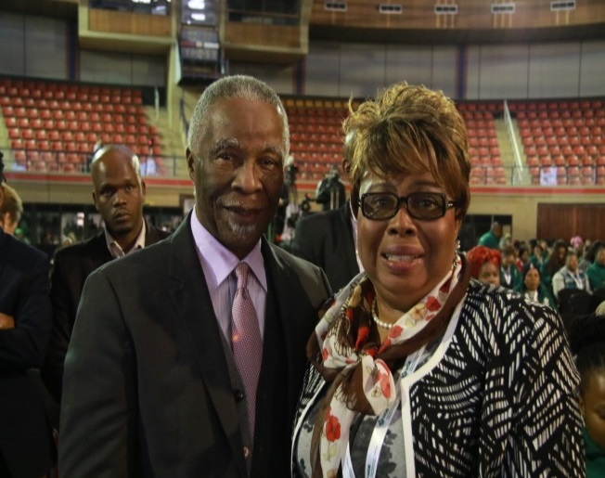
Mrs Zanele Mbeki, the Founder/Trustee of the women development banking with Dr. Omawumi Urhobo at Pretoria, South Africa
President Thabo Mbeki with Dr. Omawumi Evelyn Urhobo at the Celebrity dialogue in Pretoria, South Africa.

- LOOKING AHEAD TO 2017
In 2016, the Foundation reported some modest achievements especially in the areas of youths and empowerments, capacity building, and non-infrastructural project implementation in its five thematic areas of intervention. However, sourcing funds for project implementation still poses a big challenge to the Foundation. But the Foundation is not relenting as there is still so much to be done to bring succor to the rural and urban poor people in the Niger Delta to make their lives more meaningful and to enable them contribute to the sustainable development of the Region.
In 2017, Morgan Smart Development Foundation intend to continue to work with existing partners and meet new partners to develop programs that will have impact on poor women and youths by uplifting their businesses and building their confidence thereby ameliorate the state of poverty that permeates the region while sourcing for new partners cum donor agencies to help the foundation achieve its set objectives.
Morgan Smart Development Foundation (MSDF) in its attempt at assuaging the scourge of poverty, especially among the women in the region has been able to implement the improved choker fish smoke oven and organize business management trainings for selected women beneficiaries in Edo, Delta and Ondo States, as more efficient alternative to processing fish rather than the traditional fish smoke and drying methods.
The Foundation is working towards the deployment of 1000(one thousand) chorker fish smoking ovens and other local technologies to make food processing by the women in rural and riverine communities more efficient and less stressful.

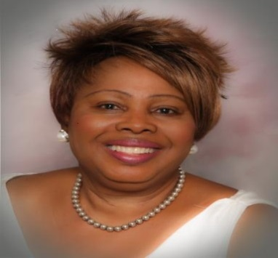
PHOTO OF THE STAFFS OF MSDF

DR EVELYN .O. URHOBO
PRESIDENT/CEO

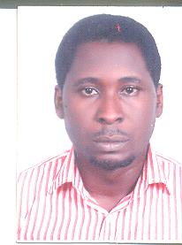
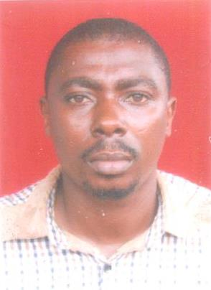
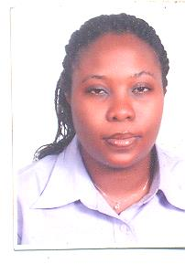
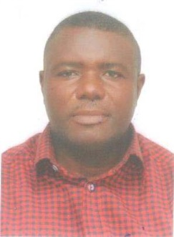

ELOMENA AKPOVIRI Project Engineer
FOLAKE ADEYEMI
Admin/Finance Officer

JEMINE IDUNDUN
Project Officer, Planning / Monitoring and Evaluation (M&E)

AYODELE DANIELS
Manager, Programmes / Projects

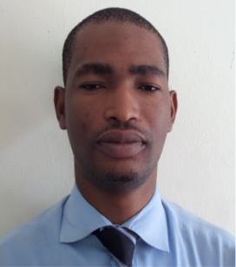
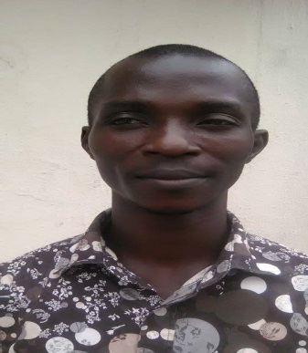
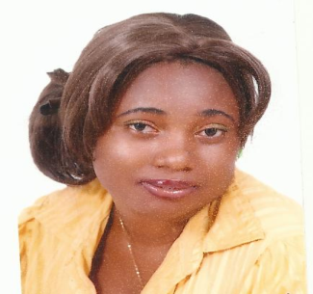

VICTORY UMUKORO
IT Officer
OLUWASEGUN OLANREWAJU
Program Officer (Capacity Building & Resource Mobilization)
EYIKIMIAGHAN OMASAN
Program Officer (Communication & Advocacy)

THELMA MORDI
Program Officer
(Admin/Gender/Fund Raising)

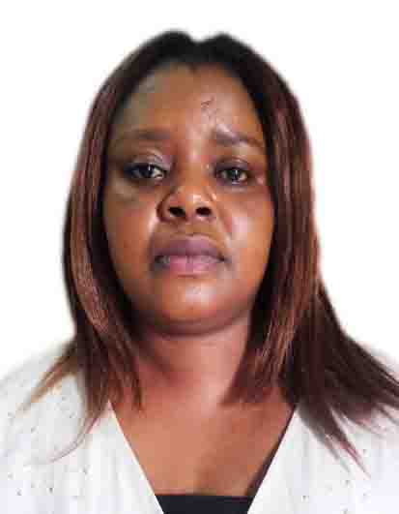
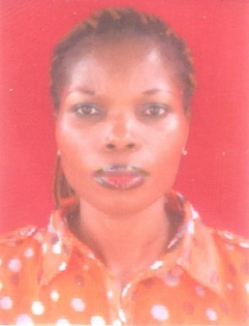
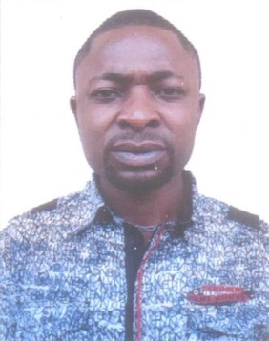
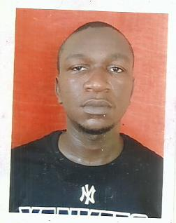
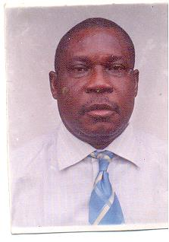
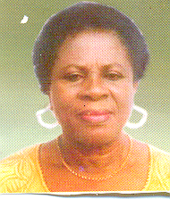
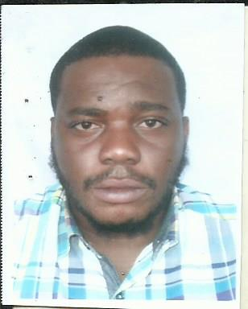
MR. JOSEPH DESTER OWOLO
Consultant to the Foundation

MRS. EVELYN IDEH
Consultant to the Foundation

BENNY ODEKA
Program Officer (Admin)

JUSTINA OGBESIA
OFFICE ASSISTANCE
DESTINY CHIDI ANI
Admin. Assistant./Driver

Andrew Oki
Admin. Assistant

CHIOMA ORJI
Program Officer (Program officer/Admin)

